How Brave Girls Helped Crack a Taboo
JAN. 15, 2014
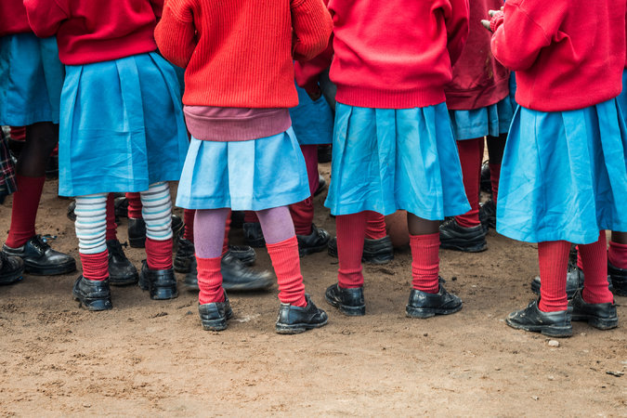
Students at a school in the Nairobi slum of Kibera that is run by Shining Hope for Communities, a grass-roots organization that is battling sexual violence.
NAIROBI, Kenya — For a window into rape culture, consider an 11-year-old girl named Flevian, who says that her grandfather has been raping her almost daily since she was in the first grade.
She’s brilliant, and, even as she lived with constant abuse and fear, she alternated between first and second in her class of more than 100. Flevian says she could have done better if she hadn’t been terrified of her grandfather’s threats to cut her throat if she told anyone about the rapes.
Yet her family and community didn’t seem to take the issue seriously, and the Kenyan police haven’t taken sexual violence seriously.
Once, when Flevian was about 8 years old, the grandfather was caught abusing her. After much discussion, the extended family decided to “purify” Flevian with traditional herbs — and left it at that.
Flevian’s fate is common. The World Health Organization estimates that 35 percent of women worldwide have been sexually assaulted or subjected to domestic violence. In the Kibera slum here in Nairobi where Flevian lives, many residents say that for a majority of women, their first sexual experience is rape.
Rapes happen partly because women and girls are devalued and blamed. In India, a poll found that 68 percent of judges believed that “provocative attire” amounts to “an invitation to rape.”
Yet there is hope. Rape thrives when it is a taboo — considered too indelicate to discuss. Now more and more women and men are speaking out, from India to Kenya to America. Here in Nairobi, there were public protests late last year after a group of young men who brutally gang-raped a 16-year-old girl were “punished” by being made to cut the grass at a police station.
In my last column, I wrote about a grass-roots organization in Kibera, Shining Hope for Communities, that is tackling the sexual violence epidemic. Now it is handling several rapes each week, pushing to get prosecutions in each one.
One of Shining Hope’s social workers, who is helping victims and their families get justice from the police, is Editar Adhiambo. She is an ebullient woman of 25 who says that she was raped at age 6 and again at 15 — and is determined to end the impunity.
It was Editar and her colleagues at Shining Hope who received a tip about Flevian and rushed to help. Words can’t capture the horror of that scene. Flevian is tiny and fragile, and she was in great pain after what she says was a particularly brutal rape. A social worker carried her to the police station.
In a terrified whisper, she identified the rapist as her grandfather, and neighbors confirmed that they had known about the abuse for years.
In this case, the system worked. The police agreed to arrest the grandfather. He insisted that he had never raped her, but the court later set bail for $4,700, an unusually high amount here. The arrest sent shock waves throughout the community because punishment for rape has been so rare.
That may be changing. In my last column I introduced Ida, a 4-year-old Kenyan girl who had been raped by a neighbor. Ida’s family made repeated visits to the Kilimani police station to seek justice, but the police kept “misplacing” documents and no arrest was made.
Yet, eventually, as in Flevian’s case, police arrested the young man whom Ida and a neighbor eyewitness identified as the rapist. Yes, my presence may have played a role in the police turnabout, but the more sustainable intervention is the constant prodding by local activists from Shining Hope for Communities.
The young man arrested gave his age as 12, although neighbors said they thought he was a few years older. He admitted the rape.
“This has had a big impact here,” Rosemary, the neighbor who caught the boy during the rape, said of the arrest. “Parents are talking to their sons, telling them to be careful.”
Write A Comment
That’s a lesson for the world, including the United States. We need to erode the sense of male entitlement, build up female empowerment, end the taboos and, above all, end the impunity.
One step that the United States could take would be for Congress to pass the International Violence Against Women Act. This wouldn’t require new spending but has been stalled for years by a combination of lack of interest and perplexing hard-line Republican opposition.
Passage wouldn’t solve the pathologies of sexual violence, but it would elevate the issue and show support for those like Ida and Flevian who could use our backing. When sexual violence is endemic worldwide, does Congress really want to continue sitting on the fence?

